MODULE-1 (HOMEWORK)

- Build your own AI assistant for grading a student based on the subjects and marks entered

Main code

subjects = {}
n = int(input("Enter number of subjects: "))

for i in range(n):
name = input("Enter subject name: ")
marks = float(input(f"Enter marks for {name}: "))
subjects[name] = marks

def grade(marks):
if marks >= 90:
return 'A+'
elif marks >= 80:
return 'A'
elif marks >= 70:
return 'B+'
elif marks >= 60:
return 'B'
elif marks >= 50:
return 'C+'
elif marks >= 40:
return 'C'
else:
return 'F'

for subject, marks in subjects.items():
print(f"{subject}: {grade(marks)}")

Output-1

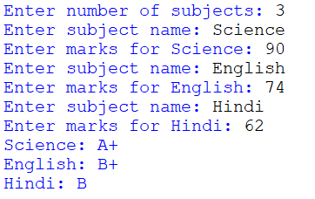

Output-2

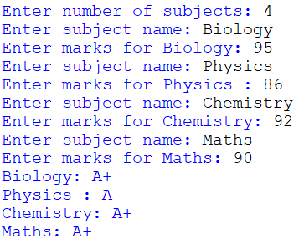

- Design a vacuum cleaner with any 4 different shapes of your choice. Each code should at least accept start, stop, left, right and dock. Rest is up to your imagination. Look, each shape offers unique advantage, now that’s something.

Main code
class Vacuum: class Vacuum:
def __init__(self, shape):
self.shape = shape
self.cleaning = False
self.docked = True

def start(self):
self.cleaning = True
self.docked = False
print(f"{self.shape} vacuum started cleaning.")

def stop(self):
self.cleaning = False
print(f"{self.shape} vacuum stopped.")

def left(self):
print(f"{self.shape} vacuum turned left.")

def right(self):
print(f"{self.shape} vacuum turned right.")

def dock(self):
self.cleaning = False
self.docked = True
print(f"{self.shape} vacuum is docked.")

def advantage(self):
if self.shape == "Circle":
return "Moves smoothly in all directions without getting stuck."
elif self.shape == "Rectangle":
return "Good for cleaning straight lines and big areas."
elif self.shape == "Triangle":
return "Can reach sharp corners easily."
elif self.shape == "Hexagon":
return "Covers a wide area quickly."
else:
return "No special advantage."

shape = input("Pick a shape for your vacuum (Circle, Rectangle, Triangle, Hexagon): ")
vacuum = Vacuum(shape)
print("Your vacuum's advantage:", vacuum.advantage())

while True:
command = input("Enter command (start, stop, left, right, dock, quit): ").lower()
if command == "start":
vacuum.start()
elif command == "stop":
vacuum.stop()
elif command == "left":
vacuum.left()
elif command == "right":
vacuum.right()
elif command == "dock":
vacuum.dock()
elif command == "quit":
print("Goodbye!")
break
else:
print("Please enter a valid command.")

Output
# when shape is a Circle 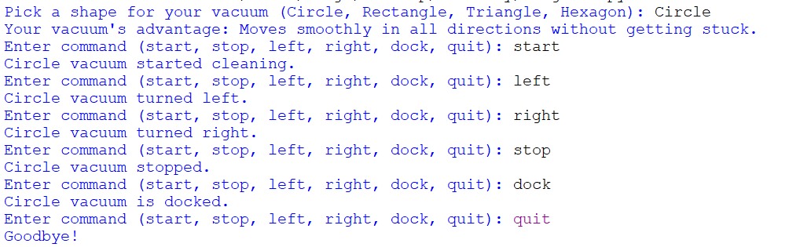
# when shape is rectangle
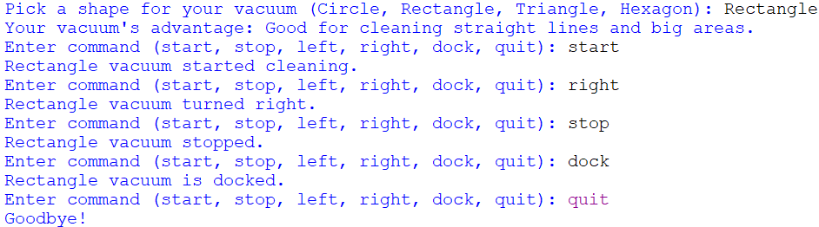

# when shape is a triangle
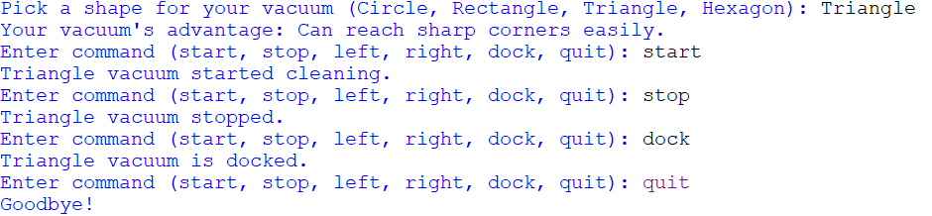
# When shape is a hexagon
